Semester 1 (Unit 3) Examination, 2017

Question/Answer Booklet

MATHEMATICS SPECIALIST

Section Two: Calculator-assumed

Student Name/Number: ______________________________________________

Teacher Name: ______________________________________________

Time allowed for this section
Reading time before commencing work: five minutes
Working time for this section: one-hundred minutes

Materials required/recommended for this section
To be provided by the supervisor: This Question/Answer Booklet
Formula Sheet

To be provided by the candidate:
Standard items: pens (blue/black preferred), pencils (including coloured), sharpener,
correction fluid/tape, eraser, ruler, highlighters
Special items: drawing instruments, templates, notes on two unfolded sheets of A4 paper, and up to three calculators approved for use in the WACE examinations

Important note to candidates
No other items may be taken into the examination room. It is your responsibility to ensure that you do not have any unauthorised notes or other items of a non-personal nature in the examination room. If you have any unauthorised material with you, hand it to the supervisor before reading any further.

Structure of this paper

Section | Number of questions available | Number of questions to be answered | Working time (minutes) | Marks available | Percentage of exam
Section One: Calculator-free | 7 | 7 | 50 | 52 | 35
Section Two: Calculator-assumed | 10 | 10 | 100 | 92 | 65
 |  |  |  |  | 100

Instructions to candidates

- The rules for the conduct of School exams are detailed in the _______________________________________School/College assessment policy. Sitting this examination implies that you agree to abide by these rules.

- Write your answers in this Question/Answer Booklet.

3. You must be careful to confine your responses to the specific questions asked and to follow any instructions that are specific to a particular question.

- Spare pages are included at the end of this booklet. They can be used for planning your responses and/or as additional space if required to continue an answer.
  - Planning: If you use the spare pages for planning, indicate this clearly at the top of the page.
  - Continuing an answer: If you need to use the space to continue an answer, indicate in the original answer space where the answer is continued, i.e. give the page number. Fill in the number of the question that you are continuing to answer at the top of the page.

- Show all working clearly. Your working should be in sufficient detail to allow your answers to be checked readily and for marks to be awarded for reasoning. Incorrect answers given without supporting reasoning cannot be allocated any marks. For any question or part question worth more than two marks, valid working or justification is required to receive full marks. If you repeat any question, ensure that you cancel the answer you do not wish to have marked.

- It is recommended that you do not use pencil, except in diagrams.

- The Formula Sheet is not to be handed in with your Question/Answer Booklet.

Section Two: Calculator-assumed (92 Marks) Weighting 65%

This section has 10 questions. Answer all questions. Write your answers in the spaces provided.

Spare pages are included at the end of this booklet. They can be used for planning your responses and/or as additional space if required to continue an answer.
  - Planning: If you use the spare pages for planning, indicate this clearly at the top of the page.
  - Continuing an answer: If you need to use the space to continue an answer, indicate in the original answer space where the answer is continued, i.e. give the page number. Fill in the number of the question that you are continuing to answer at the top of the page.

Suggested working time: 100 minutes.

Question 8 (8 marks)

The line $l$passes through the points $P\left(2,-3,5\right)$and $Q(5,1,-3)$

(a) Find a vector equation of the line $l$. (3 marks)

(b) Write down a set of parametric equations for $l$. (2 marks)

(c) Does the point $R(8,5,0)$ lie on $l$ ? Justify your answer. (3 marks)

Question 9 (10 marks)

- The mid-points of the sides of the quadrilateral $ABCD$ are the points $P,Q,R$ and $S,$ as shown below.

$D$
$R$
$C$
$S$

$A$ $Q$

$P$

$B$

Use a vector proof to show that the mid-points of any quadrilateral are the vertices of a parallelogram.

Question 9 (continued)
(b) Given is a point not on line . Let line pass through points and . If and , show that (5 marks)
Question 10 (10 marks)
The polynomial

(a) If , state all possible real roots of . (5 marks)

(b) Determine in terms of its linear factors, in the form for all values of and rational. (5 marks)

Question 11 (11 marks)
Sketch each of the following solution sets of complex numbers on the argand diagrams provided.

(a) (3 marks)
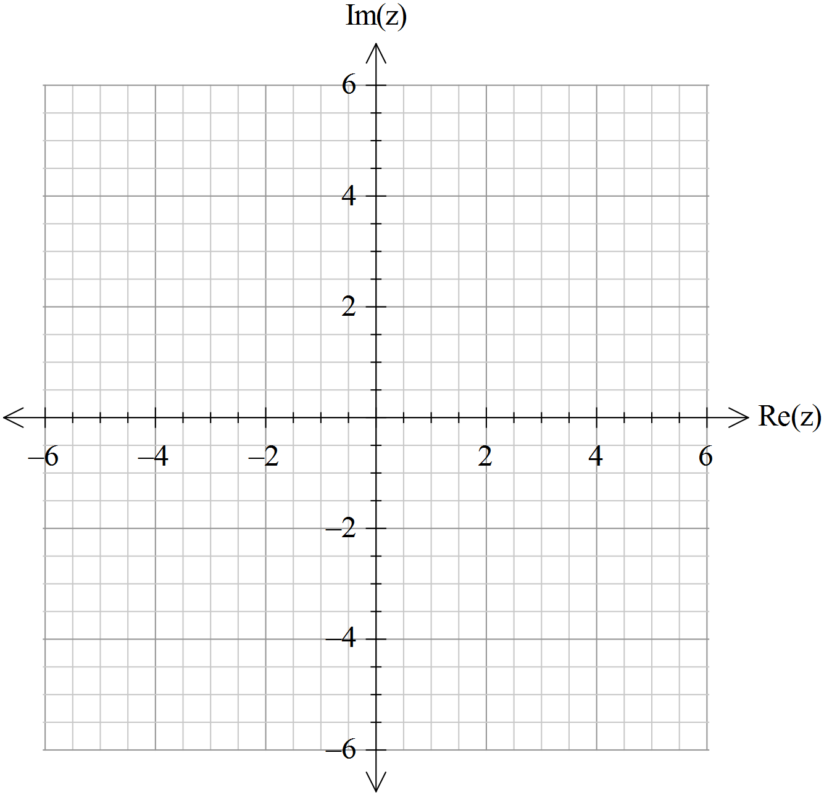

(b) (8 marks)
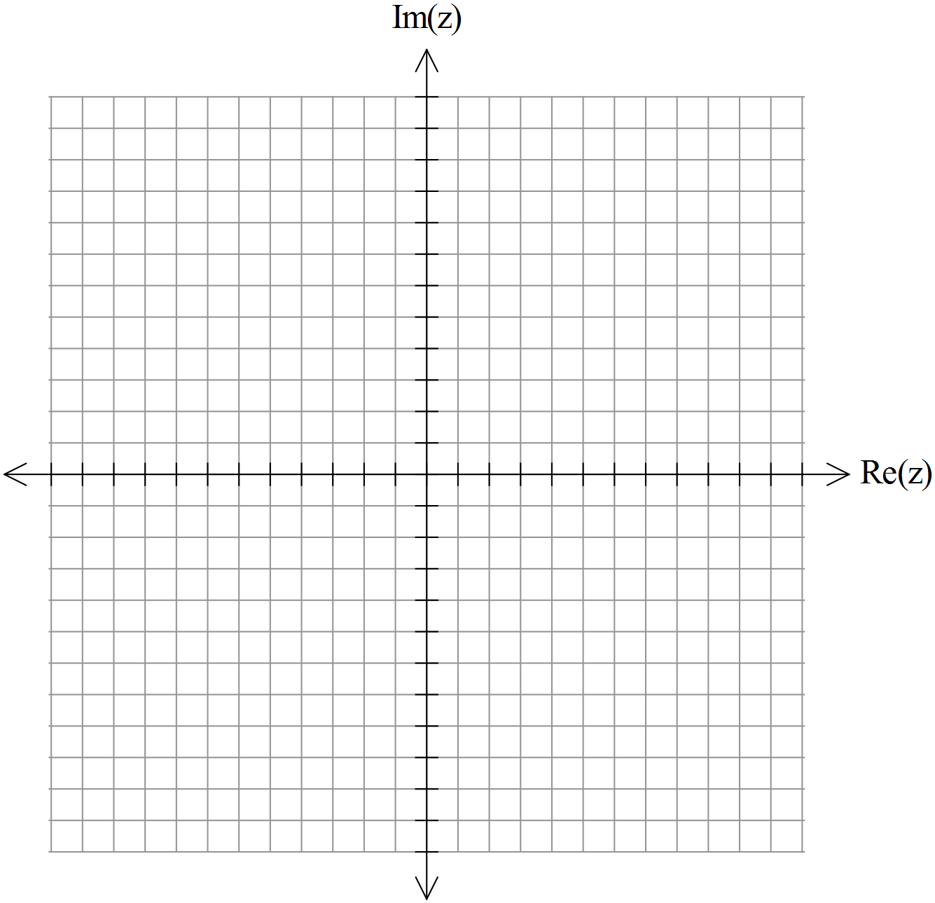
Question 12 (5 marks)

Determine the 5th roots of and plot them on the Argand plane provided below.

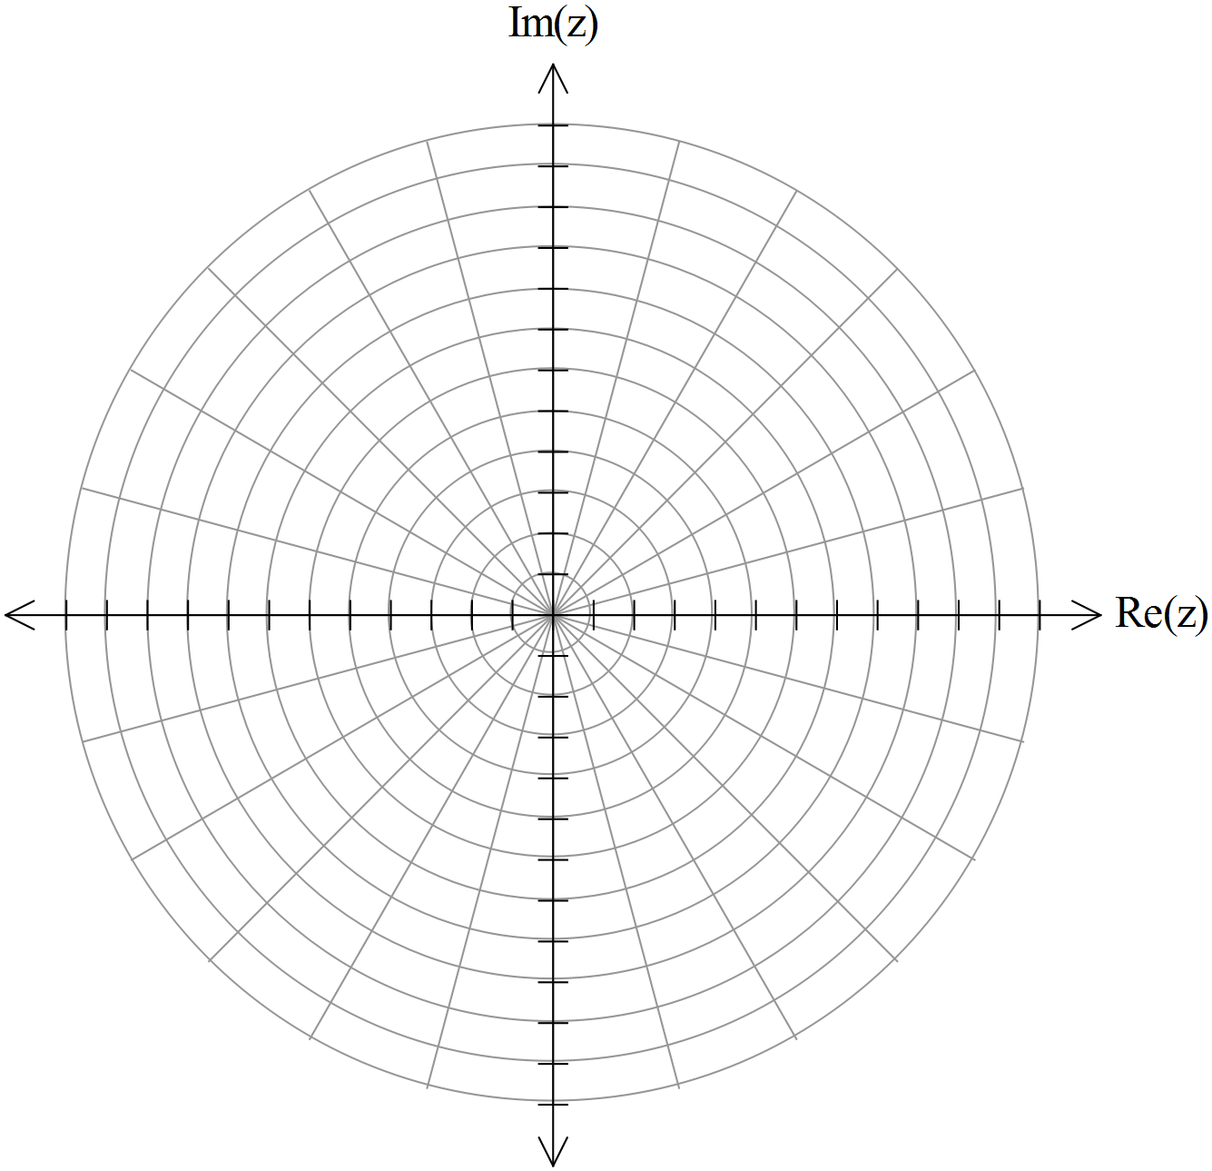
End of Questions

Question 13 (6 marks)

Given , determine .

Question 14 (7 marks)
The plane $P$intersects the coordinate axes at the points $A\left(-3,0,0\right),$ $B(0,4,0)$ and $C\left(0,0,1\right).$

(a) Use a cross product to find a vector $n$ that is normal to the plane $P$ (2 marks)

(b) Find a Cartesian equation for $P$. (2 marks)

A vector equation for the line $L$ is $r=\left(3-3t\right)i+\left(5+2t\right)j+tk.$

(c) Find the coordinates of $D,$ the point of intersection of the line $L$and plane $P$. (3 marks)

Question 15 (16 marks)
The position vector $r\left(t\right)$ of a model railway train at time $t$, in an appropriately chosen coordinate system, is given by
$r\left(t\right)=3\cos{kt i-2\sin{kt} j}$
where distances are measured in metres and time is measured in seconds after an appropriately chosen starting time. The number $k$ is positive.

(a) Obtain a Cartesian equation for the path traversed by the train. (3 marks)

(b) Describe the geometric shape of the path of the train. (1 mark)

(c) Obtain expressions for $v(t)$ and $a\left(t\right),$the velocity and acceleration at time $t.$ (2 marks)

(d) Does the train travel in a clockwise or anticlockwise direction around its closed path? Justify your answer. (2 marks)

(e) At which points on the path is the velocity perpendicular to the acceleration? (3 marks)

(f) Evaluate $k,$ correct to 3 significant figures, given that the train completes a circuit every 92 seconds. (2 marks)

(g) What is the maximum speed of the train? Justify your answer. (3 marks)

Question 16 (10 marks)

The Cartesian equation of the sphere $S$ is
$x^{2}-6x+y^{2}+z^{2}+10z=2$.

(a) Determine the radius and the coordinates of the centre of the sphere $S.$ (3 marks)

The vector equation of the line $l$ is
$$r\left(t\right)=\left(9+2t\right)i-2tj+(1+t)k$$
(b) Does the line $l$ intersect the sphere $S,$ and if so, where? (5 marks)

(c) Explain why $l$ is tangential to $S.$ (2 marks)

Question 17 (9 marks)

(a) Solve for (2 marks)

(b) Determine the value of the constant if is only true for .
(3 marks)

(c) Determine the values of the constants and such that is only true for . (4 marks)

End of Questions

Additional working space
Question number: __________________

Acknowledgements

© MAWA, 2017
This examination is Copyright but may be freely used within the school that purchases this license.
- The items that are contained in this examination are to be used solely in the school for which they are purchased.
- They are not to be shared in any manner with a school which has not purchased their own license.
- The items and the solutions/marking keys are to be kept confidentially and not copied or made available to anyone who is not a teacher at the school. Teachers may give feedback to students in the form of showing them how the work is marked but students are not to retain a copy of the paper or the marking key until the agreed release date stipulated in the purchasing agreement/license.
Published by The Mathematical Association of WA
12 Cobbler Place, MIRRABOOKA 6061.

